# **ABSTRACT**

People who want to buy property in Karachi or build a home or want to do some other work like electrical work or carpenter work or renovate their home, they find it extremely hard to search for a proper man or agent to do their work.

Through our website they can easily find agent or worker in any area of Karachi as their need. They can easily contact them and can see other people reviews and rating and can decide which agent they should hire for their work.

# **ACKNOWLEDGEMENT**

***In the name of Allah, the most Gracious and the Most Merciful.***

***Peace and blessing of Allah be upon Prophet Muhammad*ﷺ**

First, praise of Allah, for giving us this opportunity, the strength and the patience to complete our FYP finally, after the challenges and difficulties. We would like to thank our supervisor Ibrahim Hassan for his guidance, motivation and most his significant contribution in this project, expert Sohail Imran, Shah Muhammad Emad for giving us the opportunity to work on this project. We would also like to thanks our parents for financial and moral support and our friends who have helped and motivated us throughout. May Allah reward them all abundantly. Ameen

# **DEDICATION**

This report is dedicated to PAF-KIET University, our Teacher, our Supervisor, our Parents, our fellow colleagues and the hard-working students of PAF-KIET, with a hope that they will succeed in every aspect of their Academic Career and this project may help them in any aspect of their life.

Table of Contents

**ABSTRACT** i

**ACKNOWLEDGEMENT** ii

**DEDICATION** iii

**LIST OF FIGUERS** viii

**LIST OF TABLES** viii

**CHAPTER 1** 9

1. Introduction 9

1.1. Motivations 9

1.2. Problem Statement 9

1.3. Objectives and Contributions 9

1.4. Project Scope 10

1.5. Organization 10

**CHAPTER 2** 11

2. Literature Review/Process Review 11

2.1. Introduction 11

2.2. Literature Review 11

2.3. Functional and Non Functional Requirements 12

2.4. Project Significance 12

2.5. Software Platform 13

▪ Programming Language(s) 13

1. ASP.NET 13

2. SQL 13

3. C# 13

4. Java Script 13

**chapter 3** 14

3. Introduction 14

3.1. Purpose 14

3.2. Document Conventions 14

3.3. Intended Audience and Reading Suggestions 14

3.4. Product Scope 14

3.5. References 15

3.6. Product Perspective 15

3.7. Product Functions 15

3.8. User Classes and Characteristics 16

3.9. Operating Environment 16

External Interface Requirements 16

3.10. User Interfaces 16

3.11. Software Interfaces 16

3.12. Communications Interfaces 16

System Features 16

3.13. Agent Register 16

3.14. User Register 17

3.15. Agent Login 17

3.16. User Login 18

3.17. Search Agent 18

3.18. Rating and Reviews 18

3.19. Send Email 18

3.20. Send SMS 19

3.21. Schedule Email 19

3.22. Schedule SMS 19

3.23. Show Other Agents 20

3.24. Agent Ranking 20

3.25. Recommend Agents 20

3.26. History 21

3.27. History Reviews 21

**CHAPTER 4** 21

4. Projects diagrams 21

4.1. Use Case Diagram 22

4.2. Activity diagram 23

4.3. ER Diagram 29

**ALGORITHMS** 31

Naïve Bayes Algorithm 31

32

Working 32

Working in Our Project 33

Comparison with Logistic Regression 34

Comparison with Decision Tree 34

Cosine Similarity 34

Working 35

**Chapter NO 5** 36

5. Project Planning 36

5.1. Project Timeline Summary 36

5.2. Black-box Testing 36

5.3. Test Cases 38

**CHAPTER NO 6** 41

6. GUI of Website 41

6.2. Home Interface 41

6.3. Search Page 42

6.4. Send Emil Interface 42

**CHAPTER 7** 43

7. Conclusion and Future Work 43

7.1. Limitation 43

7.2. Conclusion 43

7.3. Future Works 43

References 44

Appendix 45

A. Coding – Back End Coding 45

B. Coding – Front End Javascript 46

C. SQL Server Stored Procedure 47

# **LIST OF FIGUERS**

|  |  |  |  |
| --- | --- | --- | --- |
| **S.NO** | **Figure No.** | **Figure Name** | **Page No.** |
| **1** | **Figure 4.1** | **Use Case Diagram** | **14** |
| **2** | **Figure 4.2** | **Activity Diagram** | **15** |
| **3** | **Figure 4.3** | **ER Diagram** | **21** |

# **LIST OF TABLES**

|  |  |  |  |
| --- | --- | --- | --- |
| **S.NO** | **TABLE NO.** | **TABLE NAME** | **PAGE NO.** |
| **1** | **Table No. 1.1** | **Training Dataset for Naïve Bayes Algorithm** | **25** |

# **CHAPTER 1**

## Introduction

. Real Estate means property, it could be land or building.

Buying a house or property is one of the most difficult decisions for the citizens of Karachi. It should be in right area, near with your office and there shouldn’t be any problem of electricity or water or any other problem.

Likewise building a home is also a big problem. You should pass the map and get all the necessary documents clear and then hire a builder. Different builders have different rate, you should choose one correctly and then you would need to hire electrician, plumber, carpenter and other workers for building home.

We have designed this website so that you can find all the agents and workers at one place.

### Motivations

As I am living in Gulshan-e-Maymar and the real estate business is going very high in this area. People are coming from city to this outskirt area of Karachi as it is very peaceful and not congested like other areas of Karachi.

They find it difficult to whom they contact, they search for a trusted agent for their work and sometimes they got cheated. So, by seeing their difficulty we find a solution to make a website where they can find agents easily.

### Problem Statement

The difficulty face by the people when buying home or building a home or the maintenance of the home that whom they should contact or consult. They shouldn’t get deceive by any agent taking huge commission or selling a low cost home or land at high cost.

### Objectives and Contributions

* .User can search agent in specific area, in specific block and type
* User can contact agent through e-mail and sms
* User can set reminder email and sms if agent is busy
* User can give rating and reviews to the agent
* User can see top rank agent in overall Karachi based on reviews
* User can see recommended agent
* User can see history

### Project Scope

As we know the real estate business is increasing day by day. People are investing their money in real estate sector. People are migrating from villages to cities. The price of real estate is increasing rapidly. New projects are building like Bahria Town and Scheme 33. So, the need of real estate agent and worker is also increasing.

When people want to buy a home or build a home they look for a specific agent or contractor for their work and it is a difficult. As Karachi is a big city and here are so many agents and it is difficult to search for a specific agent in a specific area.

So, here we come with a solution. People need to enter the area they will see all the agents in that area along with their rating and reviews, so they can decide themselves which agent they should contact for their work and it is an easy task as compared to the conventional way that they are visiting different agents and contacting and they are buying newspapers and searching for agents and sometimes they are charged higher price by the agent.

So, as the real estate business is growing rapidly there are chances that our project scope will also increase and people will use it more

### Organization

Organizing a real estate project website is a difficult but we manage to deal with it.

We meet the real estate agents in different areas of Karachi and gather the data, we ask them about their business and gather the information.

We build the project using agile methodology we divide the task and we build most of the project in weekend days.

# **CHAPTER 2**

## Literature Review/Process Review

We have read and reviewed different literature and articles about real estate and we have personally visited different agents and collect the information

### Introduction

Real estate means land, building or property. People who deal in buying and selling of real estate are known as real estate agents.

Real estate agents get the information of the people who are selling their property and when someone come to buy the property they sell it on 1% commission.

Real estate investors invest in the real estate business by buying any property, plot or home and then sell it when a buyer comes in profit.

Builder builds home and then sell it in profit. In GulshaneMaymar builders are making 10 lakh profit on 200 sq. yard plot approximately.

### Literature Review

Real estate sector is growing in Pakistan rapidly. Foreign real estate investors are also investing in Pakistan from Gulf and Asian countries. Pakistan is spending $2.5 billion on construction per year.

DHA City Karachi experienced moderate growth for both 250 sq yard and 500 sq yard options. The former went up by 3.28%, while the latter increased by 3.09%. In the past few months, rates had been dropping, leading to an ideal situation for investors to come in and generate activity in the locality.

Bahria Town Karachi experienced downward trends, with 250 sq yard plots dropping by a moderate 1.81%, and rates of 500 sq yard plots going down by a stable 0.23%.

According to Zameen.com report, the real estate market of Karachi, stability prevailed for the most part, with a few notable exceptions where there were moderate rises and drops. Societies where development was being undertaken at an encouraging pace were more popular, whereas investors were still taking a backseat to see how the elections would play out.

### Functional and Non Functional Requirements

#### Functional Requirements

* Sending Email
* Sending SMS
* Sending Remainder Email
* Sending Remainder SMS
* Calculate rating
* Showing reviews
* Calculate ranking
* Show recommended agents
* Login
* Sign up
* Showing previous history

#### Non-Functional Requirements

* Product Requirement: User should have internet, should have a valid email address and mobile number.
* Accessibility: The user can easily access it and can see the agents detail easily by signing up.
* Reliability: It is reliable and performing all the task
* Performance: It is performing well. User can see his raring and reviews as he click on submit button. Email and SMS is also going.
* Security: User can make his account and can contact agent through his account and no one else can use his account.

### Project Significance

This project is very much important because everyone needs to hire someone for his household work like electrical work, plumber work, carpenter work etc. and for this purpose we are providing an easy access to these workers. Anyone while setting in his home can search for the desire people and hire him. There is no need to go outside and search for the people and exhaust you.

If you want to build a home or buy a property you can do that easily while setting at your home you can see their previous record and can choose the best one.

### Software Platform

* Microsoft Windows or any other operating system
* Browser

## Programming Language(s)

### ASP.NET

### SQL

### C#

### Java Script

# **chapter 3**

# Introduction

## Purpose

This website is about real estate and construction services. We are providing real estate agents and workers through this website. As the real estate business is going high the scope of the product is also high. This is the 1st release of the product.

## Document Conventions

This document follows Arial format. Bold text was used for headings and sub section headings.

## Intended Audience and Reading Suggestions

This document is intended for the development team and other stakeholders. This document also contains diagrams and working of algorithms.

## Product Scope

This product is going to be used by real estate agents and the people who have any work from agents. As too many people are doing real estate works and the property business is going high day by day so the scope of this product is high too.

When people want to buy a home or build a home they look for a specific agent or contractor for their work and it is a difficult. As Karachi is a big city and here are so many agents and it is difficult to search for a specific agent in a specific area.

So, here we come with a solution. People need to enter the area they will see all the agents in that area along with their rating and reviews, so they can decide themselves which agent they should contact for their work and it is an easy task as compared to the conventional way that they are visiting different agents and contacting and they are buying newspapers and searching for agents and sometimes they are charged higher price by the agent.

So, as the real estate business is growing rapidly there are chances that our project scope will also increase and people will use it more

## References

1. 1] http://www.saedsayad.com/naive_bayesian.htm
2. [2] https://www.mikesdotnetting.com/article/254/scheduled-tasks-in-asp-net-with-quartz-net
3. [3] https://www.codeproject.com/Questions/631284/How-to-pass-an-array-to-SQL-SERVER-stored-pro
4. [4] https://en.wikipedia.org/wiki/Real_estate_in_Pakistan
5. [5] https://datascience.stackexchange.com/questions/1229/cosine-similarity-for-ratings-recommendations-why-use-it
6. [6] <https://en.wikipedia.org/wiki/Use_case_diagram>
7. [[7](#_Activity_diagram_(diagram)] <https://en.wikipedia.org/wiki/Activity_diagram>
8. [8] <https://www.smartdraw.com/entity-relationship-diagram/>
9. [9] http://abctutorial.com/Post/24/how-to-upload-image-in-database-and-displaying-it-using-aspnet-mvc-%7C-jquery-ajax
10. [10] http://davidstutz.de/bootstrap-multiselect/
11. [11] http://csharp.net-informations.com/communications/csharp-smtp-mail.htm
12. [12] https://imlaak.com/pakistan-real-estate-forecast-2018/

## Product Perspective

It is a new type of website which register the information of real estate agents and other related workers. It stores the information of real estate agents, do ranking and schedule email and sms.

## Product Functions

* Search Agents
* Show Agents Detail
* Send Email
* Send SMS
* Schedule Email
* Schedule SMS
* Rating
* Reviews
* Ranking
* Recommendation
* History

## User Classes and Characteristics

User would be able to search agents in specific area, in specific block and of specific type

He would be able to show details of the agents, rate them, write reviews, see others rating and reviews. He would be able email agents, send sms, schedule email and sms see ranking of the agents and see the recommended agents.

## Operating Environment

* Windows
* Browser

# External Interface Requirements

## User Interfaces

User interface design is very easy. User can easily interact with the website. The menu bar at the top will let the user navigate through website with ease. User don’t need to spend his time to understand the working of the website. It is simple.

## Software Interfaces

* It runs best on Windows Operating System
* A browser which supports c#, Javascript

## Communications Interfaces

* User need internet connection to run the website
* User can send email
* User can send sms
* User can give reviews

# System Features

## Agent Register

* + 1. Description and Priority

Agents and workers from different areas of Karachi will register themselves so that the users can contact them. Priority is high.

* + 1. Stimulus/Response Sequences
* Agent will go on login form
* Agent will click on link” Register yourself ”
* Agent will fill the required details
* Agent will submit the form
  + 1. Functional Requirements

Valid Email: Agent should have a valid email address

Valid phone no.: Agent should have a valid phone no.

## User Register

* + 1. Description and Priority

User from different areas of Karachi will register themselves so that the users can see the details of the agent and can contact them. Priority is high.

* + 1. Stimulus/Response Sequences
* User will go on login form
* User will click on link” Register yourself ”
* User will fill the required details
* User will submit the form
  + 1. Functional Requirements
* Valid Email: Agent should have a valid email address
* Valid phone no.: Agent should have a valid phone no.

## Agent Login

* + 1. Description and Priority: Agent will login the website so that they can contact other agents. Priority is high.
    2. Stimulus/Response Sequences
* Agent will click on login button and login page will open
* Agent will enter login credentials and will submit
* If login will be successful homepage will appear otherwise same page will appear
  + 1. Functional Requirements
* Email and Password: He should remember his login email and password

## User Login

* + 1. Description and Priority: User will login the website so that they can contact other agents. Priority is high.
    2. Stimulus/Response Sequences
* User will click on login button and login page will open
* User will enter login credentials and will submit
* If login will be successful homepage will appear otherwise same page will appear
  + 1. Functional Requirements
* Email and Password: He should remember his login email and password

## Search Agent

* + 1. Description and Priority: User will search agent of his type so he can contact them. Priority is high
    2. Response Sequence
* User will go on search agent page
* User will select his area and search agent.
* User will select area and block and will serach
* Or user can select area, block and type and can search too

## Rating and Reviews

* + 1. Description and Priority: User can give reviews and rating to the agent priority high
    2. Response Sequence
* User will search agent and click on agent details
* At he bottom of detail page user will give rating and reviews
  + 1. Functional Requirement
* Search Agent: User should first search the agent
* Detail: System should show the detail

## Send Email

* + 1. Description and Priority: User can send email to the agent to contact him. Priority is medium.
    2. Response Sequence:
* User will search agent and click on agent details.
* In detail view user will click send email
* New window will open and user will type subject and enter message and will click send.
  + 1. Functional Requirement
* User must be login to send email.

## Send SMS

* + 1. Description and Priority: User can send SMS to the agent to contact him. Priority is medium.
    2. Response Sequence:
* User will search agent and click on agent details.
* In detail view user will click send sms
* New window will open and user will type message and will click send.
  + 1. Functional Requirement
* User must be login to send sms.

## Schedule Email

* + 1. Description and Priority: User can schedule email if agent is busy, the email will be sent automatically on scheduled time. Priority is medium.
    2. Response Sequence:
* User will search agent and click on agent details.
* In detail view user will click schedule email
* New window will open and user will type subject and enter message andwill enter the schedule time and will click send.
  + 1. Functional Requirement
* User must be login to schedule email.

## Schedule SMS

* + 1. Description and Priority: User can schedule sms if agent is busy. Priority is medium.
    2. Response Sequence:
* User will search agent and click on agent details.
* In detail view user will click schedule sms
* New window will open and user will type smst and enter message and enter the schedule time and will click send.
  + 1. Functional Requirement
* User must be login to schedule sms.

## Show Other Agents

* + 1. Description and Priority: User can see the other agents if the required agent is busy. Priority is medium
    2. Response Sequence:
* User will search agent and click on agent details.
* In detail view user will click show other agents
* Other agents in specific area will be shown
  + 1. Functional Requirement
* User must be login to see other agents.

## Agent Ranking

* + 1. Description and Priority: User can see the agents ranking based on reviews. Priority is medium.
    2. Response Sequence:
* User will click on agent ranking.
* Agents will be shown in ascendind order according to their rank
  + 1. Functional Requirement
* User must be login to see agent ranking.
* Enough users reviews should be given to the agents to show top agents.

## Recommend Agents

* + 1. Description and Priority: User can see the recommended agents based on area, type and rating. Priority is medium.
    2. Response Sequence:
* User will click on recommended agents and new page will open.
* User will select area and type and click search
* Recommended agents will be shown
  + 1. Functional Requirement
* User must be login to see recommended agents.

## History

* + 1. Description and Priority: User can see his previous to which agent he give reviews and comments. Priority is medium.
    2. Response Sequence:
* User will click on history.
* Previos agents will be shown up.
  + 1. Functional Requirement
* User must be login to see history.
* User must give someone reviews and rating which will be show

## History Reviews

* + 1. Description and Priority: User can his previous reviews and ratings. Priority is medium.
    2. Response Sequence:
* User will click on history
* User will click on reviews of which agent agent he want to see.
* User reviews and ratings will appear on next page.
  + 1. Functional Requirement
* User must be login to see history.
* User must give someone review and rate.

# **CHAPTER 4**

## Projects diagrams

Based on the above literature review and project scope here are some diagrams, which illustrates that what will be our project or the system is capable to reach the desired results.

### Use Case Diagram

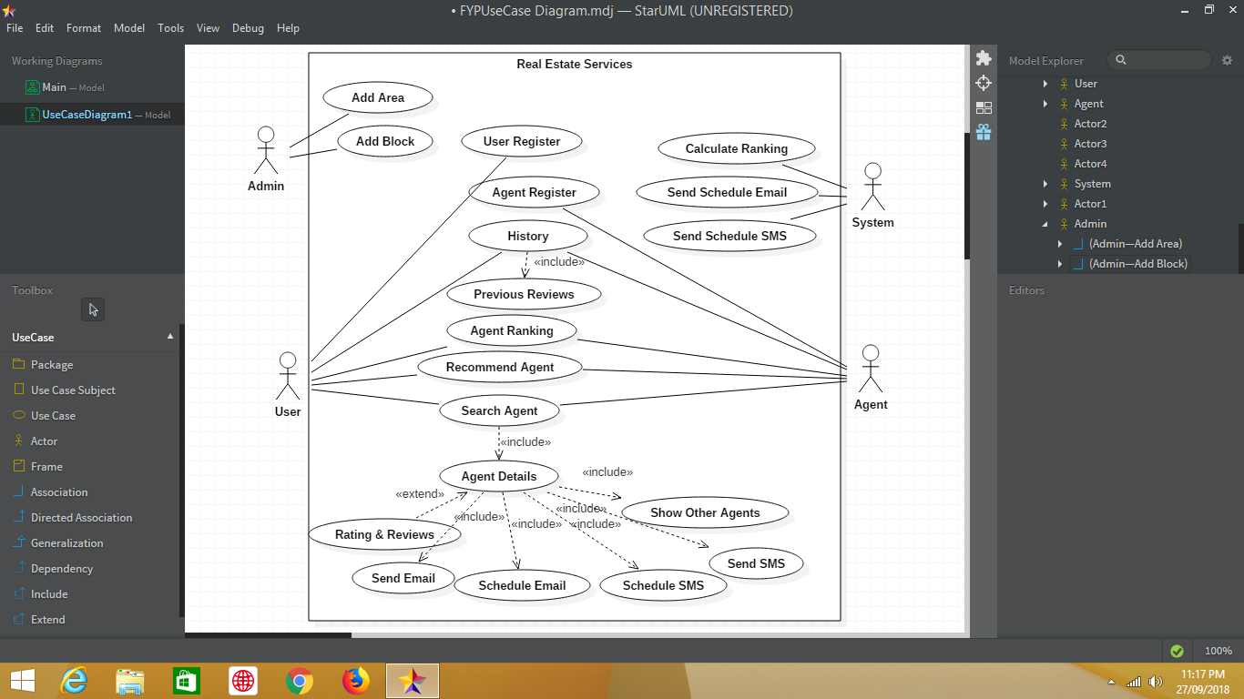

### Activity diagram

* User Register

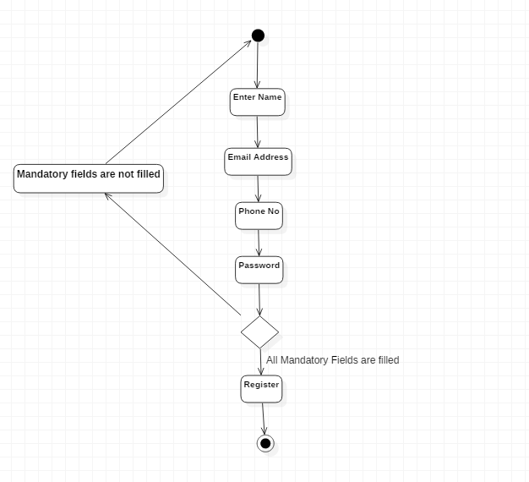

* Search Agent

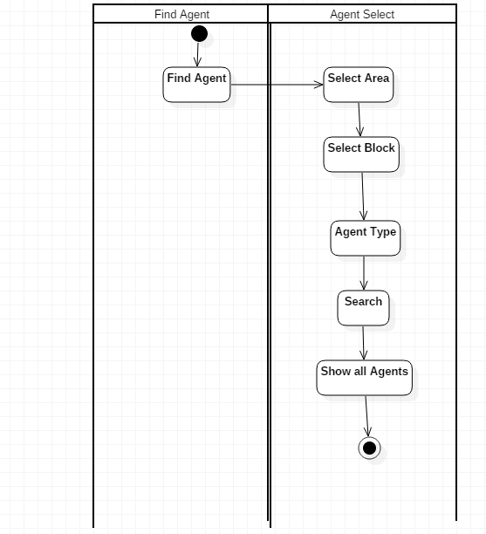

* Schedule Email

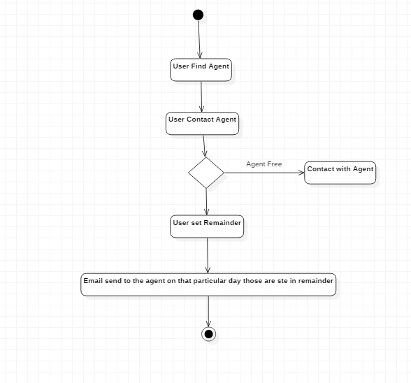

* User Send Message to the Agent

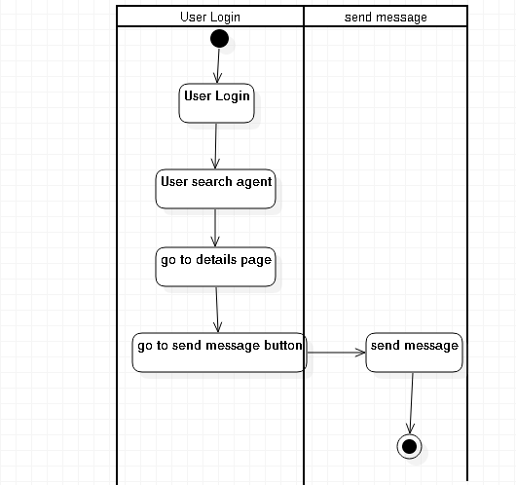

* User Send Email to the Agent

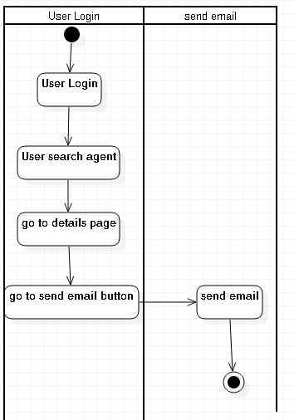

* Recommendation Algorithm

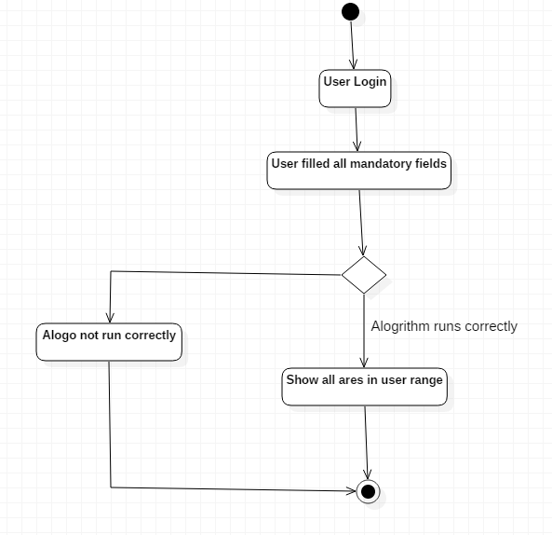

### ER Diagram

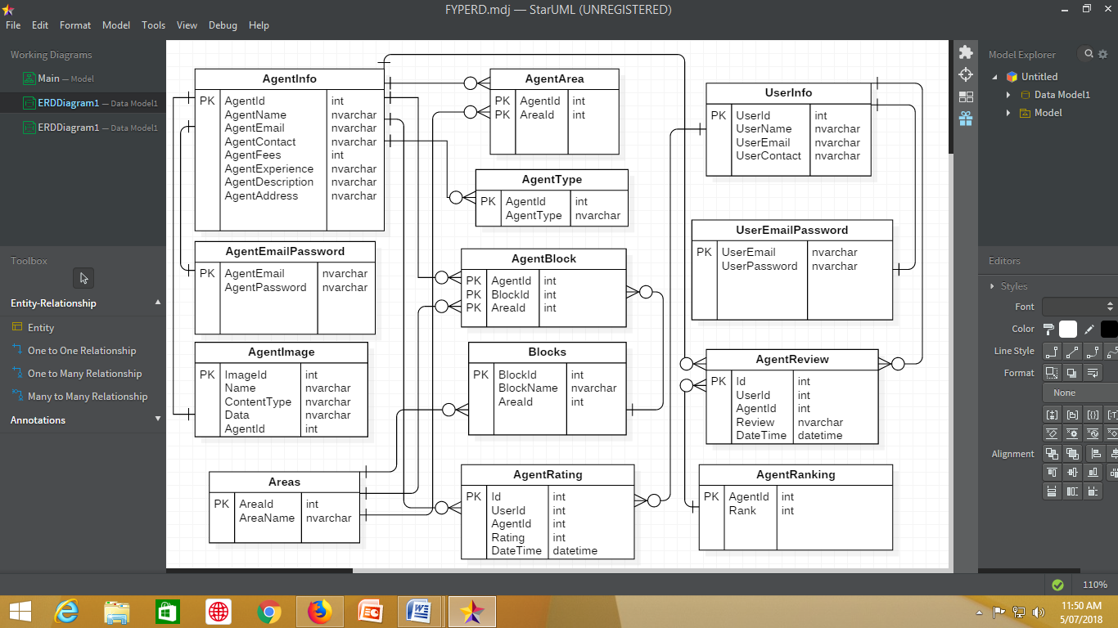

.

##### SQL:

SQL is a domain-specific language used in programming and designed for managing data held in a relational database management system (RDBMS), or for stream processing in a relational data stream management system (RDSMS). It is particularly useful in handling structured data where there are relations between different entities/variables of the data. SQL offers two main advantages over older read/write APIs like ISAM or VSAM: first, it introduced the concept of accessing many records with one single command; and second, it eliminates the need to specify *how* to reach a record, e.g. with or without an index.

**JAVASCRIPT**

JavaScript is a programming language commonly used in web development. It was originally developed by Netscape as a means to add dynamic and interactive elements to websites. While JavaScript is influenced by Java, the syntax is more similar to C and is based on ECMAScript, a scripting language developed by Sun Microsystems.

JavaScript is a client-side scripting language, which means the source code is processed by the client's web browser rather than on the web server. This means JavaScript functions can run after a webpage has loaded without communicating with the server. For example, a JavaScript function may check a web form before it is submitted to make sure all the required fields have been filled out. The JavaScript code can produce an error message before any information is actually transmitted to the server.

**VISUAL STUDIO CODE**

Visual Studio Code is a lightweight but powerful source code editor, which runs on your desktop and is available for Windows, MacOS and Linux. It comes with built-in support for JavaScript, Typescript and Node.js and has a rich ecosystem of extensions for other languages (such as C++, C#, Python, PHP, Go) and runtimes (such as .NET and Unity).

# **ALGORITHMS**

We have used Naïve Bayes and Cosine Similarity algorithms in our project. Naïve Bayes is used for ranking and cosine similarity is used for recommendation

## Naïve Bayes Algorithm

Naïve Bayes is independent of features. Each word is treated having no connection with other word in a sentence. It works on conditional **probability**. Conditional probability is the probability that something will happen, giventhatsomethingelse **has already occurred**.

Where,

P(C|X) is posterior probability

P(X|C) is likelihood

P(C) is class prior probability

P(X) is predictor prior probability

For positive comments:

For negative comments

Now we can compare the probabilities of positive and negative comments

First we will find the ratio

# 

The product can be very small so we take log

So, this is the formula which we used in our project.

## Working

We use it in our project like

For positive comments prior probability

P(P) =

=117/100+117 = 0.5391

For negative comments prior probability

P(N) =

=100/100+117 = 0.460

To calculate the likelihood of a positive word

=

For example the word “about” appears in positive comments 2 times so

We will add 1 for smoothing

= 0.0256

So we will calculate the training data:

|  |  |  |  |  |
| --- | --- | --- | --- | --- |
| Words | In Positive Comments | In Negative Comments | P(ωi|P) | P(ωi|N) |
| about | 2 | 1 | 0.02564 | 0.02 |
| again | 1 | 0 | 0.0170 | 0.01 |
| Alhamdulilah | 1 | 0 | 0.0170 | 0.01 |
| Amazing | 2 | 0 | 0.02564 | 0.01 |
| and | 4 | 3 | 0.04273 | 0.04 |
| awesome | 4 | 0 | 0.04273 | 0.01 |
| completed | 2 | 2 | 0,02564 | 0.02564 |
| bhai | 3 | 2 | 0.03418 | 0.02564 |
| fast | 1 | 0 | 0.02 | 0.01 |
| bad | 0 | 6 | 0.01 | 0.07 |
| cheap | 0 | 1 | 0.01 | 0.02 |
| cheater | 0 | 0 | 0.01 | 0.02564 |

Training dataset of Naïve Bayes Algorithm

## Working in Our Project

For example the user has commented to an agent like

“awesome work thankyou”

Its probability will be calculated like

=log

= 2.73051

= 2.73051 >0

So it is a positive comment.

## Comparison with Logistic Regression

* Naïve Bayes converge quicker as compare to the logistic regression
* Naïve Bayes works well with less training data.

## Comparison with Decision Tree

* Decision trees divide the data into squares so building clusters means it has to split a lot to encompass clusters of data. Splitting a lot leads to complex trees and raises probability of overfitting
* In decision tree tall trees pruned which build cluster so some feature might be lost

## Cosine Similarity

We have used cosine similarity for agent recommendation. User will select the area and type and in the database the agent having similar area, type and rating having greater 60 will be recommended to the user.

Cosine similarity algorithm is a popular way of quantifying the similarity of sequences by treating them as vectors and calculating their cosine. This delivers a value between 0 and 1; where 0 means no similarity whatsoever and 1 meaning that both sequences are exactly the same.

Given two vectors of attributes, A and B, the cosine similarity, cos (θ), is represented using a dot product and magnitude as

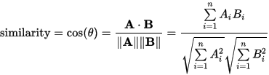

## Working

Let’s say user has selected area Gulshan e Maymar and type is property and rating is greater than 60. So vector a would be

A = (1,1,1,0)

and XYZ agent works in Maymar and his type is property and his rating is less than 60

So vector b would be

B = (1,1,0,1)

Now,

A . B=1*1+1*1+1*0+0*1

= 2

Now

||A||=1*1+1*1+1*1+0*0

= 12 + 12 + 12 = 3

And

||B||=1*1+1*1+0*0+1*1

= 12 + 12 + 12 =3

Now,

= 0.666

As 0.666 < 1 so the two vectors are not similar.

# **Chapter NO 5**

## Project Planning

We have planned the project last year and it took one year to complete the project with other courses.

### Project Timeline Summary

* We started the project in August last month
* 1st and 2nd week we made diagrams
* Then in September we start making our project by making login and registration form
* In October we work on agent searching by area and blocks
* In November we search agent by block, area and type and we work on agent details
* In December we were busy in final exams so we didn’t work much
* In January we work on reviews and comment
* In February we work on ranking and naïve bayes algorithm
* In march we work on recommendation and cosine similarity algorithm
* In april we work on history and email and sms
* In may we work on email and sms scheduling
* In june we test and finalize the project

### Black-box Testing

Black Box Testing, also known as Behavioral Testing, is a software testing method in which the internal structure/ design/ implementation of the item being tested is not known to the tester. These tests can be functional or non-functional, though usually functional.Testing, either functional or non-functional, without reference to the internal structure of the component or system.

Thistechnique is theprocedure to derive and/or select test cases based on ananalysis of the specification, either functional or non-functional, of a component or systemwithout reference to its internal structure.

Black Box testing method is applicable to the following levels of software testing:

* Integration Testing
* System Testing
* Acceptance Testing

The higher the level, and hence the bigger and more complex the box, the more black box testing method comes into use.

#### System Testing

**System Testing** is a level of the software testing where a complete and integrated software is tested. The purpose of this test is to evaluate the system’s compliance with the specified requirements.The process of testing an integrated system to verify that it meets specifiedrequirements. System testing is the testing of a complete and fully integrated software product. Usually software is only one element of a larger computer based system. Ultimately, software is interfaced with other software/hardware systems. System testing is actually a series of different tests whose sole purpose is to exercise the full computer based system. System testing involves testing the fully integrated applications including external peripherals in order to check how components interact with one another and with the system as a whole. This is also called End-to-End testing scenario. Verify thorough testing of every input in the application to check for desired outputs. Testing of the user's experience with the application. .

That is a very basic description of what is involved in system testing. You need to build detailed test cases and test suites that test each aspect of the application as seen from the outside without looking at the actual source code.

#### Integration Testing

Integration Testing is a level of software testing where individual units are combined and tested as a group. The purpose of this level of testing is to expose faults in the interaction between integrated units. Test drivers and test stubs are used to assist in Integration Testing. Testing performed to expose defects in the interfaces and in the interactions between integrated components or systems. Component integration testing, system integration testing. Component integration testing performed to expose defects in the interfaces and interaction between integrated components. System integration testing the integration of systems and packages; testing interfaces to external organizations (e.g. Electronic Data Interchange, Internet).

#### Unit Testing

Unit testing is a level of software testing where individual units/ components of a software are tested. The purpose is to validate that each unit of the software performs as designed.Unit is the smallest testable part of software. It usually has one or a few inputs and usually a single output. In procedural programming, a unit may be an individual program, function, procedure, etc. In object-oriented programming, the smallest unit is a method, which may belong to a base/ super class, abstract class or derived/ child class. Unit testing frameworks, drivers, stubs, and mock/ fake objects are used to assist in unit testing. Unit Testing is normally performed by software developers themselves or their peers. In rare cases,independent software testers may also perform it.

#### User Acceptance Testing

User acceptance testing (UAT) is the last phase of the software testing process. During UAT, actual software users test the software to make sure it can handle required tasks in real-world scenarios, according to specifications. UAT is one of the final and critical software project procedures that must occur before newly developed software is rolled out to the market. UAT is also known as beta testing, application testing or end user testing. UAT directly involves the intended users of the software. UAT can be implemented by making software available for a free beta trial on the internet or through an in-house testing team comprised of actual software users.

### Test Cases

A test case is a set of conditions or variables under which a tester will determine whether a system under test satisfies requirements or works correctly. The process of developing test cases can also help find problems in the requirements or design of an application.

##### 

##### TEST CASE # 1

**Test Case Title: Check Agent Rank**

|  |  |
| --- | --- |
| Preconditions: Login and go to agent details |  |
| Actions: Give review to agent |  |
| Expected Results: Agent rank change in database either +1 or -1 |  |
| Tested By: Sajid |  |
| Result: Rank changed | Pass/Fail: pass |

##### TEST CASE # 2

**Test Case Title: Schedule Email**

|  |  |
| --- | --- |
| Preconditions: Login and go to agent details |  |
| Actions: enter date and time,enter message and subject and send |  |
| Expected Results: Email will be sent on schedule time |  |
| Tested By: Sajid |  |
| Result: Email was sent on scheduled time | Pass/Fail: pass |

##### TEST CASE # 3

**Test Case Title: Agent Recommendation**

|  |  |
| --- | --- |
| Preconditions: Login and go to agent recommend page. |  |
| Actions: Select area and type and click on search |  |
| Expected Results: Agents of those area, and of those type and have rating greater than 60 would be shown. |  |
| Tested By: Sajid |  |
| Result: Agents were shown | Pass/Fail: Pass |

##### TEST CASE # 4

**Test Case Title: Review and Rating**

|  |  |
| --- | --- |
| Preconditions: Login and go to details |  |
| Actions: Give from five star rating and write reviews. |  |
| Expected Results: Rating and reviews will be updated |  |
| Tested By: Sajid |  |
| Result: Rating and reviews were updated | Pass/Fail: Pass |

# **CHAPTER NO 6**

## GUI of Website

* 1. **Login Interface**

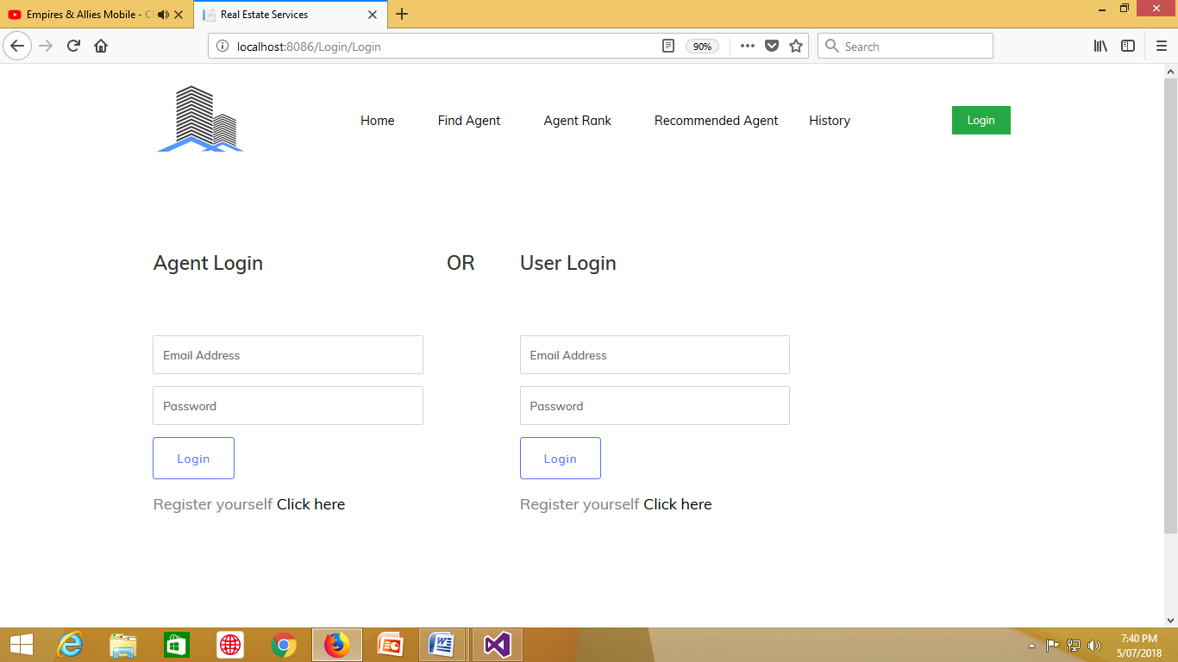

### Home Interface



### Search Page

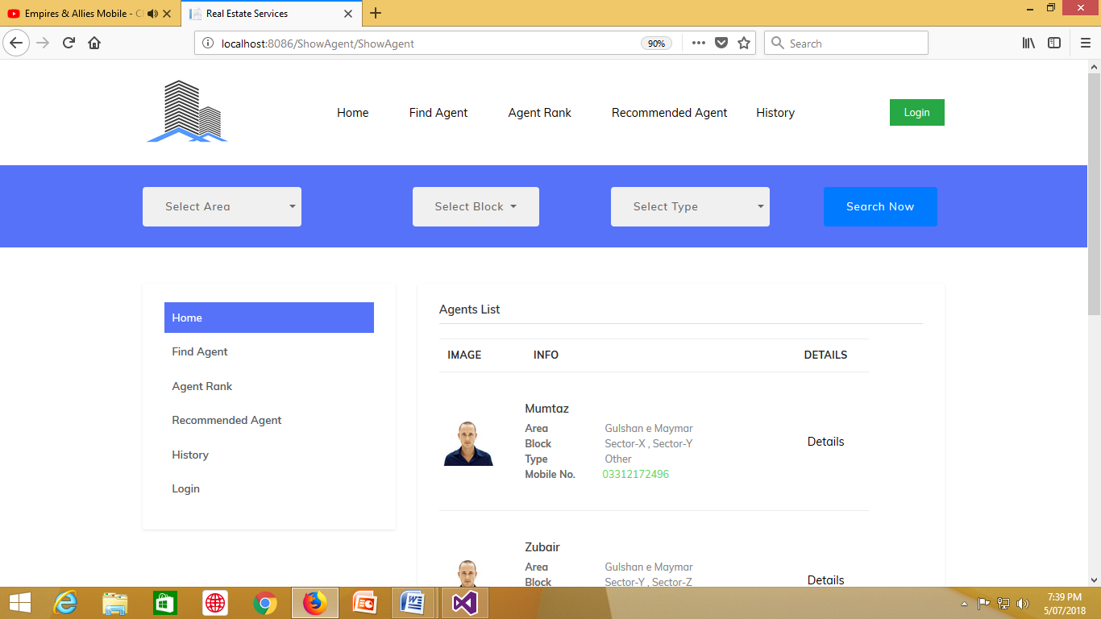

### Send Emil Interface

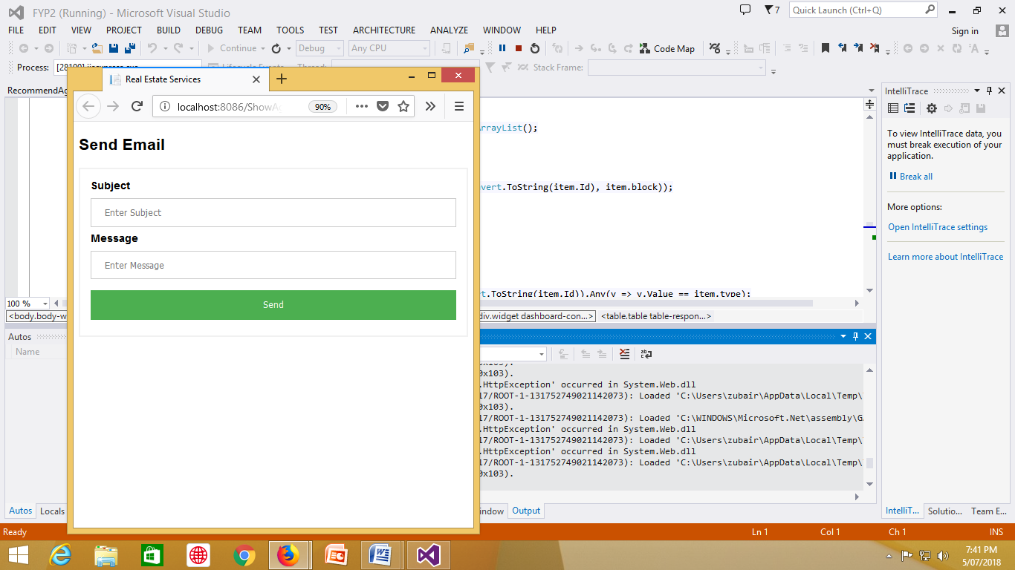

# **CHAPTER 7**

## Conclusion and Future Work

### Limitation

* No private messages between user and agent
* Agent and user once enter their information can’t change it
* No pagination

### Conclusion

In conclusion, we have developed a website which can store agent information and other real estate workers and usres can retrieve the information and can contact them wherever they want. We develop it by using c#, HTML, CSS, Javascript and database and we have learned a lot.

### Future Works

There is always a chance of improvement, following are the aspects where the system requires some time to be analyzed and modified

* Improve user interface.
* More searching feature with recommendation algorithm
* Enhance application functionality.

# References

[1] http://www.saedsayad.com/naive_bayesian.htm

[2] https://www.mikesdotnetting.com/article/254/scheduled-tasks-in-asp-net-with-quartz-net

[3] https://www.codeproject.com/Questions/631284/How-to-pass-an-array-to-SQL-SERVER-stored-pro

[4] https://en.wikipedia.org/wiki/Real_estate_in_Pakistan

[5] https://datascience.stackexchange.com/questions/1229/cosine-similarity-for-ratings-recommendations-why-use-it

[6] <https://en.wikipedia.org/wiki/Use_case_diagram>

[[7](#_Activity_diagram_(diagram)] <https://en.wikipedia.org/wiki/Activity_diagram>

[8] <https://www.smartdraw.com/entity-relationship-diagram/>

[9] http://abctutorial.com/Post/24/how-to-upload-image-in-database-and-displaying-it-using-aspnet-mvc-%7C-jquery-ajax

[10] http://davidstutz.de/bootstrap-multiselect/

[11] http://csharp.net-informations.com/communications/csharp-smtp-mail.htm

[12] https://imlaak.com/pakistan-real-estate-forecast-2018/

# Appendix

## Coding – Back End Coding

public int GetRanking(string id)

{

SqlCommand cmd = new SqlCommand("getscore", DBConnection.GetConnection());

cmd.CommandType = CommandType.StoredProcedure;

cmd.Parameters.AddWithValue("@agentid", id);

object score = cmd.ExecuteScalar();

if (score != DBNull.Value)

return Convert.ToInt32(score);

else

return 0;

}

public int AgentrRankExist(string id)

{

SqlCommand cmd = new SqlCommand("checkagentrank", DBConnection.GetConnection());

cmd.CommandType = CommandType.StoredProcedure;

cmd.Parameters.AddWithValue("@agentid", id);

object score = cmd.ExecuteScalar();

if (score != DBNull.Value)

return Convert.ToInt32(score);

else

return 0;

}

public void updaterank(string id, int rank)

{

SqlCommand cmd = new SqlCommand("updatescore", DBConnection.GetConnection());

cmd.CommandType = CommandType.StoredProcedure;

cmd.Parameters.AddWithValue("@id", id);

cmd.Parameters.AddWithValue("@score", rank);

cmd.ExecuteReader();

}

public void insertrank(string id, int rank)

{

SqlCommand cmd = new SqlCommand("insertscore", DBConnection.GetConnection());

cmd.CommandType = CommandType.StoredProcedure;

cmd.Parameters.AddWithValue("@id", id);

cmd.Parameters.AddWithValue("@score", rank);

cmd.ExecuteReader();

}

public List<ShowAgentVariables> GetAgent()

{

List<ShowAgentVariables> agentlist = new List<ShowAgentVariables>();

SqlCommand cmd = new SqlCommand("ShowAgentRank", DBConnection.GetConnection());

cmd.CommandType = CommandType.StoredProcedure;

//cmd.Parameters.AddWithValue("@area", a.SelectArea);

SqlDataAdapter sd = new SqlDataAdapter(cmd);

DataTable dt = new DataTable();

sd.Fill(dt);

foreach (DataRow dr in dt.Rows)

{

agentlist.Add(

new ShowAgentVariables

{

Id = Convert.ToInt32(dr["AgentId"]),

Name = Convert.ToString(dr["Agent_name"]),

ContactNo = Convert.ToString(dr["Agent_contact"]),

area = Convert.ToString(dr["Areas"]),

email = Convert.ToString(dr["Agent_email"]),

type = Convert.ToString(dr["Agent_type"]),

//For pic

ContentType = dr["ContentType"].ToString(),

Data = (byte[])dr["Data"],

imageName = dr["Name"].ToString(),

});

}

return agentlist;

}

## Coding – Front End Javascript

<script type="text/javascript">

$(document).ready(function () {

$('#areas').change(function () {

$('#blocks option').remove();

$.getJSON('/AgentAreaController/GetBlocks', { AreaID: $('#areas').val() }, function (data) {

$.each(data, function () {

$('#blocks').append('<option value=' +

this + '>' + this + '</option>');

});

$("#blocks").multiselect('destroy');

$('#blocks').multiselect({

includeSelectAllOption: true

});

}).fail(function (jqXHR, textStatus, errorThrown) {

alert('Error getting products!');

});

});

});

$("#agents tr").click(function () {

window.document.location = "http://www.yourwebsiteurl.com/newpage.html";

});

</script>

<script type="text/javascript">

$(function () {

$('#blocks').multiselect({

includeSelectAllOption: true

});

});

## SQL Server Stored Procedure

ALTER PROCEDURE [dbo].[AgentListRecomenAlgo]

@List AS dbo.AgentList READONLY

AS

BEGIN

SET NOCOUNT ON;

select AgentId,AgentArea,Agent_type from tblAgentArea1 full outer join tblAgent_Type1 on Agent_Id=AgentId where AgentId in (

SELECT Agentid FROM @List);

END



**Pakistan Air Force**

**Karachi Institute of Economics & Technology**

**Real Estate Services Website**

**Submitted by:**

**Zubair Arif (58435)**

**Haris Ahsan (59094)**

**Advisor:**

Sir Ibrahim Hassan

College of Computing & Information Sciences

A final year project report presented to the College of Computing & Information Sciences, Pakistan Air Force – Karachi Institute of Economics & Technology in partial fulfillment of the requirements of the degree of Bachelor of Science

**2018**